## NAME: AKACHI IKWU

## SUBJECT: SIT103

## STUDENT_ID: 221320482

## 2.2)

**a) 1)**PATIENT [Patient Card Num (PK), First_Name, Last_Name, Home_address, Age, Diagnosis].

I considered it an entity because in my business scenario, the entity Patient gives information and it is of importance to database in the hospital. It is also an entity because data can be stored in it.

2) DISPENSARY [Drug Name (PK), Drug Strength, Company Name (FK).

I considered it an entity because in my business scenario, the entity Drug is given by Doctors information about the drug (s) is written down and it is of importance to database in the hospital. It is also an entity because data can be stored in it.

3) STAFF [ Staff_ID (PK), First_Name, Last_Name,Address, Phone, Area of Work, salary ].

I considered it an entity because in my business scenario, the entity Staff gives information and it is of importance to database in the hospital. It is also an entity because data can be stored in it.

4) DOCTOR [ Doctor Name (PK), Specialization, Phone, Salary].

I considered it an entity because in my business scenario, the entity Doctor gives information and it is of importance to database in the hospital. It is also an entity because data can be stored in it.

5) LABORATORY [ Patient_Card_number (PK), Report,Doctor_name].

I considered it an entity because in my business scenario, the entity Laboratory gives information for example Lab report and it is of importance to database in the hospital. It is also an entity because data can be stored in it.

6) RADIOGRAPHY [ Patient_ID (PK), Patient name, Report, Doctor name (FK) ].

I considered it an entity because in my business scenario, the entity Radiography gives information also and it is of importance to database in the hospital. It is also an entity because data can be stored in it.

7) ACCOUNT DEPARTMENT [ Doctor_Name (PK), Doctor_bank_acct, day_salary, Staff_bank_acct ].

I considered it an entity because in my business scenario, the entity Account Department gives information and it is of importance to database in the hospital. It is also an entity because data can be stored in it.

8) PRESCRIPTION [Prescription_Card_num (PK), Prescription_Date, Doctor_Name].

I considered it an entity because in my business scenario, the entity Prescription gives information because the entity Doctor PRESCRIBES drugs and it is of importance to database in the hospital. It is also an entity because data can be stored in it.

9) PERCENT [ Doctor_name (PK), Patient_seen, Doctor_bank_acct (FK) ].

I considered it an entity because in my business scenario, the entity Percent gives information because the entity Doctor are paid daily (when the consult in the days that is not their day of work) according to the number of Patients seen and it is of importance to database in the hospital. It is also an entitybecause data can be stored in it.

10) BILL [Patient_card num (PK), Reason for payment, Amount paid].

I considered it an entity because in my business scenario, the entity Bill gives information and bills are paid by the entity Patient and it is of importance to database in the hospital. It is also an entity because data can be stored in it.

**b)**  I considered them entities because with my business scenario in Part 1 (1.2), they are objects that exist and data can be stored in them and also it is of close importance to database.

2.3)**A** The entity PATIENT is already in 1NF because it has no multiple values in any row and has a PK.

The entity is already in 2NF because it is in 1NF and there are no partial dependent.

The entity is already in 3NF because it is in 2NF and no non key is transitively dependent.

**B)**The entity DOCTOR is already in 1NF because it has no multiple values in any row and has a PK.

The entity is already in 2NF because it is in 1NF and there are no partial dependent.

The entity is already in 3NF because it is in 2NF and no non key is transitively dependency.

**C)** The entity DISPENSARY is already in 1NF because it has no multiple values in any row and has a PK.

The entity is already in 2NF because it is in 1NF and there are no partial dependent.

The entity is already in 3NF because it is in 2NF and no non key is transitively dependency.

**D)** The entity LABORATORY is in 1NF because it has no multiple values and has a PK.

The entity is in 2NF because it is in 1NF and there are no partial dependent.

The entity is in 3NF because it is in 2NF and the non keys are not depending on each other.

**E)** The entity ACCT DEPARTMENT is in 1NF because it has no multiple values and has a PK.

The entity is in 2NF because it is 1NF and there are no partial dependent.

The entity is in 3NF because it is 2NF and the non keys are not depending on each other.

**G)** The entity RADIOGRAPHY is in 1NF because it has no multiple values and a PK.

The entity is in 2NF because it is in 1NF and there areno partial dependent.

The entity is in 3NF because it is 2NF and the non keys are not depending on each other.

**H)** The entity PRESCRIPTION is in 1NF because it has no multiple values and a PK.

The entity is in 2NF because it is in 1NF and there are no partial dependent.

The entity is in 3NF because it is in 2NF and the non keys are not depending on each other.

**I)** The entity BILL is in 1NF because it has no multiple values and has a PK.

The entity is in 2NF because it is in 1NF and there are no partial dependent.

The entity is in 3NF because it is 2NF and the non keys are not depending on each other.

**J)**The entity PERCENT is in 1NF because it has no multiple values and has a PK.

The entity is in 2NF because it is in 1NF and there are no partial dependent.

The entity is in 3NF because it is 2NF and the non keys are not depending on each other.

**K)**The entity STAFF is in 1NF because it has no multiple values and has a PK.

The entity is in 2NF because it is in 1NF and there are no partial dependent.

The entity is not in 3NF because the non keys are depending on each other.

**CONVERSION TO 3NF**

To achieve 3NF

1. Remove the transitive dependent from the table.
2. Place them in a new table with the determinant as the PK.
3. Leave the determinant in the original table.

**STAFF**

|  |  |  |  |  |
| --- | --- | --- | --- | --- |
| **Staff_ID** | Staff_name | Phone | Area of work | Salary |

Transitive dependent

**JOBTYPE**

|  |  |
| --- | --- |
| **Area of work** | Salary |

**JUSTIFICATION OF JOBTYPE**

I considered it an entity because in my business scenario, the entity Staff are paid a certain amount depending on their job type information and it is of importance to database in the hospital. It is also an entity because data can be stored in it.

**STAFF**

|  |  |  |  |
| --- | --- | --- | --- |
| **Staff_ID** | Staff_name | Phone | **Area of work** |

**2.4) Entity Relationship Diagram**

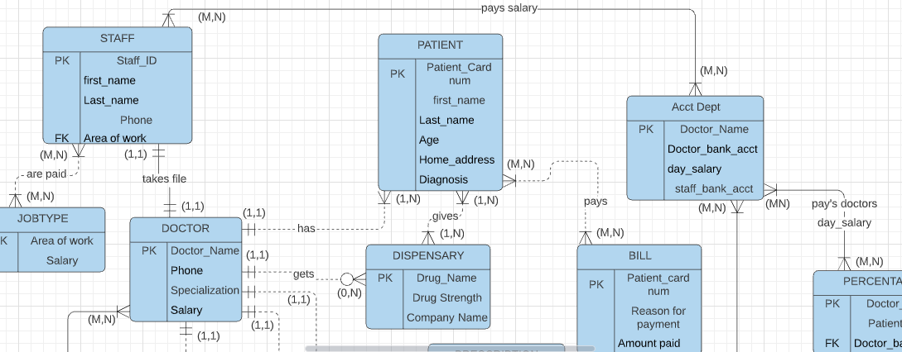

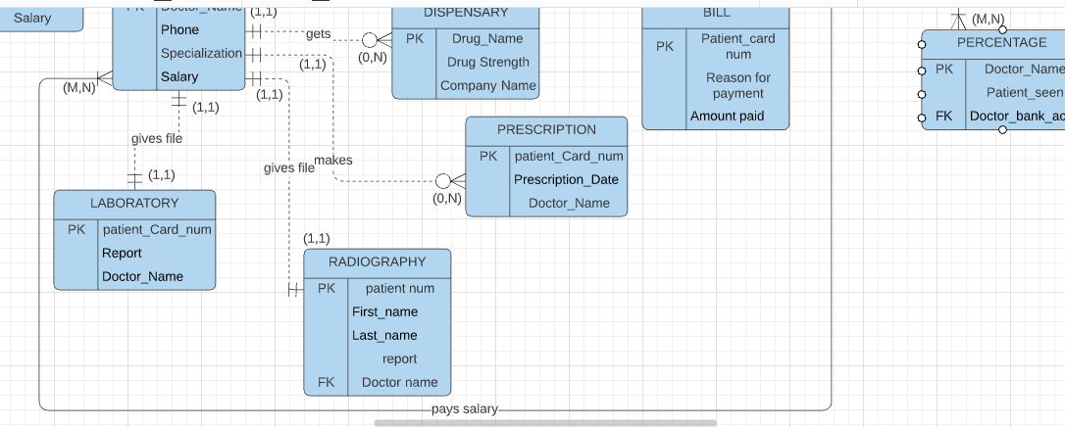

**2.5) Implementation of the database schema**

--doctor

CREATETABLE doctor(

 Doctor_Name  VARCHAR2 (15) NOTNULL,

Phone NUMBER (11,0)  NOTNULL,

 Specialization  VARCHAR2 (15)  NOTNULL,

 salary  NUMBERNOTNULL,

 CONSTRAINT pk_doctor  PRIMARYKEY (Doctor_Name)

);

--bill

CREATETABLE bill(

patient_Card_num   NUMBER (5,0) NOTNULL,

First_name     VARCHAR2 (15)  NOTNULL,

Last_name   VARCHAR2 (15)  NOTNULL,

Pay_reason     VARCHAR2 (15) NOTNULL,

Amount_paid     NUMBERNOTNULL,

CONSTRAINT pk_bill   PRIMARYKEY  (patient_card_num)

);

--prescription

CREATETABLE prescription(

patient_Card_num  NUMBER (5,0) NOTNULL,

prescription_Date  DATENOTNULL,

Doctor_Name   VARCHAR2 (15) NOTNULL,

CONSTRAINT pk_prescription  PRIMARYKEY (patient_Card_num)

);

--patient

CREATETABLE patient(

  patient_Card_num  NUMBER (5,0)  NOTNULL,

First_name   VARCHAR2 (15)  NOTNULL,

Last_name  VARCHAR2 (15)  NOTNULL,

Age       INT  NOTNULL,

Home_address VARCHAR2 (15)  NOTNULL,

Diagnosis  VARCHAR2 (15)  NOTNULL,

CONSTRAINT pk_patient   PRIMARYKEY (patient_Card_num)

);

--dispensary

CREATETABLE dispensary(

Drug_name  VARCHAR2 (15)  NOTNULL,

Drug_strength   VARCHAR2 (15)  NOTNULL,

Company_name   VARCHAR2 (15),

CONSTRAINT pk_dispensary   PRIMARYKEY (Drug_name)

);

--percentage

CREATETABLE percent(

 Doctor_Name  VARCHAR2 (15)  NOTNULL,

 Patient_seen  VARCHAR2 (15) NOTNULL,

 Doctor_bank_acct   NUMBER  NOTNULL,  --fk

CONSTRAINT pk_percent  PRIMARYKEY  (Doctor_Name),

CONSTRAINT fk_Doctor_bank_acct  FOREIGN KEY (Doctor_bank_acct)  REFERENCES account_department (Doctor_bank_acct)

);

--jobtype

CREATETABLE jobtype(

area  VARCHAR2 (15),

Salary  NUMBERNOTNULL,

CONSTRAINT pk_jobtype  PRIMARYKEY (area),

CHECK (salary >=0)

);

--staff

CREATETABLE staff(

 staff_ID  NUMBERNOTNULL,

First_name VARCHAR2 (15)  NOTNULL,

Last_name  VARCHAR2 (15) NOTNULL,

 Phone   NUMBERNOTNULL,

 Area   VARCHAR2 (15),  --fk

 CONSTRAINT pk_staff   PRIMARYKEY (staff_ID),

 CONSTRAINT  fk_Area   FOREIGN KEY (Area)  REFERENCES jobtype (area)

);

--laboratory

CREATETABLE laboratory(

 patient_Card_num  NUMBER (5,0) NOTNULL,

 Report   VARCHAR2 (15)  NOTNULL,

 Doctor_Name  VARCHAR2 (15) NOTNULL  ,

 CONSTRAINT  pk_laboratory  PRIMARYKEY (patient_Card_num)

);

--radiography

CREATETABLE radiography (

 patient_number  NUMBERNOTNULL,

 First_name VARCHAR2 (15)  NOTNULL,

 Last_name   VARCHAR2 (15)  NOTNULL,

 report  VARCHAR2 (15)  NOTNULL,

 Doctor_Name  VARCHAR2 (15) NOTNULL,  --fk

CONSTRAINT pk_radiography  PRIMARYKEY (patient_number),

CONSTRAINT fk_Doctor_Name  FOREIGN KEY (Doctor_Name) REFERENCES doctor (Doctor_Name)

);

--account_department

CREATETABLE account_department(

    Doctor_bank_acct NUMBER (10,0)  NOTNULL,

    Doctor_Name   VARCHAR2 (15)  NOTNULL,

    Day_salary NUMBERNOTNULL,

    staff_bank_acct NUMBER (15,0)  NOTNULL,

CONSTRAINT pk_account_department  PRIMARYKEY  (Doctor_bank_acct)

);

**2.6) INSERTING OF DATA**

Insertinto PATIENT  (PATIENT_CARD_NUM,FIRST_NAME,LAST_NAME,AGE,HOME_ADDRESS,DIAGNOSIS) values   (25784,'Clara','Okoro',34,'34 World Bank','Pregnant');

Insertinto PATIENT  (PATIENT_CARD_NUM,FIRST_NAME,LAST_NAME,AGE,HOME_ADDRESS,DIAGNOSIS) values   (14689,'Akachi','Ikwu',21,'10 Eze Street','Ovarian Cyst');

Insertinto PATIENT  (PATIENT_CARD_NUM,FIRST_NAME,LAST_NAME,AGE,HOME_ADDRESS,DIAGNOSIS) values   (38245,'Alex','Duru',1,'Orji Road','Malaria');

Insertinto PATIENT  (PATIENT_CARD_NUM,FIRST_NAME,LAST_NAME,AGE,HOME_ADDRESS,DIAGNOSIS) values   (17349,'Ngozi','Chikere',27,'Amakohia Road','Pregnant');

Insertinto PATIENT  (PATIENT_CARD_NUM,FIRST_NAME,LAST_NAME,AGE,HOME_ADDRESS,DIAGNOSIS) values   (65277,'Gloria','Mbah',12,'3 Fabian Osuji','Cancer');

Insertinto PATIENT  (PATIENT_CARD_NUM,FIRST_NAME,LAST_NAME,AGE,HOME_ADDRESS,DIAGNOSIS) values   (37896,'Angela','Oke',31,'Mgbidi','Fibrod');

Insertinto PATIENT  (PATIENT_CARD_NUM,FIRST_NAME,LAST_NAME,AGE,HOME_ADDRESS,DIAGNOSIS) values   (85465,'Lucia','Mezu',24,'Akwakuma','Appendix');

Insertinto PATIENT  (PATIENT_CARD_NUM,FIRST_NAME,LAST_NAME,AGE,HOME_ADDRESS,DIAGNOSIS) values   (35897,'Nnamdi','Okafor',78,'345 Umuodu','Stroke');

Insertinto PATIENT  (PATIENT_CARD_NUM,FIRST_NAME,LAST_NAME,AGE,HOME_ADDRESS,DIAGNOSIS) values    (11289,'Joy','Uwa',23,'Imsu Junction','Pregnant');

Insertinto PATIENT  (PATIENT_CARD_NUM,FIRST_NAME,LAST_NAME,AGE,HOME_ADDRESS,DIAGNOSIS) values   (12876,'Sylvia','Nwa',26,'1 Royce Road','pregnant');

Insertinto PERCENT  (DOCTOR_NAME,PATIENT_SEEN,DOCTOR_BANK_ACCT)  Values  ('Dr Oba',50,2259975065);

Insertinto PERCENT  (DOCTOR_NAME,PATIENT_SEEN,DOCTOR_BANK_ACCT)  Values  ('Dr Okpukpu',30,0787362386);

Insertinto PERCENT  (DOCTOR_NAME,PATIENT_SEEN,DOCTOR_BANK_ACCT)  Values  ('Dr Onu',70,8715875441);

Insertinto PERCENT  (DOCTOR_NAME,PATIENT_SEEN,DOCTOR_BANK_ACCT)  Values  ('Dr Uba',40,0018356267);

Insertinto PERCENT  (DOCTOR_NAME,PATIENT_SEEN,DOCTOR_BANK_ACCT)  Values  ('Dr Yemi',80,7512468666);

Insertinto PERCENT  (DOCTOR_NAME,PATIENT_SEEN,DOCTOR_BANK_ACCT)  Values  ('Dr Bola',30,4557235643);

Insertinto PERCENT  (DOCTOR_NAME,PATIENT_SEEN,DOCTOR_BANK_ACCT)  Values  ('Dr Edozie',53,0025676954);

Insertinto account_department (Doctor_Name,Doctor_bank_acct,Day_salary,staff_bank_acct)  Values   ('Dr Oba',2259975065,50000,4677985740);

Insertinto account_department (Doctor_Name,Doctor_bank_acct,Day_salary,staff_bank_acct)  Values   ('Dr Okpukpu',0787362386,30000,1397675547);

Insertinto account_department (Doctor_Name,Doctor_bank_acct,Day_salary,staff_bank_acct)  Values   ('Dr Onu',8715875441,70000,0043567965);

Insertinto account_department (Doctor_Name,Doctor_bank_acct,Day_salary,staff_bank_acct)  Values   ('Dr Uba',0018356267,40000,4579934220);

Insertinto account_department (Doctor_Name,Doctor_bank_acct,Day_salary,staff_bank_acct)  Values   ('Dr Yemi',7512468666,80000,342438789);

Insertinto account_department (Doctor_Name,Doctor_bank_acct,Day_salary,staff_bank_acct)  Values   ('Dr Bola',4557235643,30000,0734685420);

Insertinto account_department (Doctor_Name,Doctor_bank_acct,Day_salary,staff_bank_acct)  Values   ('Dr Edozie',0025676954,53000,4267585236);

Insertinto laboratory  (PATIENT_CARD_NUM,Report,Doctor_Name)  Values   (25784,'Positive','Dr Oba');

Insertinto laboratory  (PATIENT_CARD_NUM,Report,Doctor_Name)  Values   (14689,'blood clear','Dr Oba');

Insertinto laboratory  (PATIENT_CARD_NUM,Report,Doctor_Name)  Values   (38245,'Malaria','Dr Onu');

Insertinto laboratory  (PATIENT_CARD_NUM,Report,Doctor_Name)  Values   (17349,'Positive','Dr Anumagulu');

Insertinto laboratory  (PATIENT_CARD_NUM,Report,Doctor_Name)  Values   (65277,'Cancer positive','Dr Onu');

Insertinto laboratory  (PATIENT_CARD_NUM,Report,Doctor_Name)  Values   (37896,'Fibroid','Dr Okorochukwu');

Insertinto laboratory  (PATIENT_CARD_NUM,Report,Doctor_Name)  Values   (85465,'Blood Clear','Dr Uba');

Insertinto laboratory  (PATIENT_CARD_NUM,Report,Doctor_Name)  Values   (35897,'Ischemic stroke','Dr Yemi');

Insertinto laboratory  (PATIENT_CARD_NUM,Report,Doctor_Name)  Values   (11289,'Positive','Dr Okpukpu');

Insertinto laboratory  (PATIENT_CARD_NUM,Report,Doctor_Name)  Values   (12876,'Positive','Dr Bola');

Insertinto BILL  (PATIENT_CARD_NUM,First_name,Last_name,Pay_reason,Amount_paid)  values (25784,'Clara','Okoro','lab test',6000);

Insertinto BILL  (PATIENT_CARD_NUM,First_name,Last_name,Pay_reason,Amount_paid)  values (14689,'Akachi','Ikwu','scan',9000);

Insertinto BILL  (PATIENT_CARD_NUM,First_name,Last_name,Pay_reason,Amount_paid)  values (38245,'Alex','Duru','lab test',2000);

Insertinto BILL  (PATIENT_CARD_NUM,First_name,Last_name,Pay_reason,Amount_paid)  values (17349,'Ngozi','Chikere','scan',1000);

Insertinto BILL  (PATIENT_CARD_NUM,First_name,Last_name,Pay_reason,Amount_paid)  values (65277,'Gloria','Mbah','lab test',8000);

Insertinto BILL  (PATIENT_CARD_NUM,First_name,Last_name,Pay_reason,Amount_paid)  values (37896,'Angela','Oke','scan',1000);

Insertinto BILL  (PATIENT_CARD_NUM,First_name,Last_name,Pay_reason,Amount_paid)  values (85465,'Lucia','Mezu','scan',1000);

Insertinto JOBTYPE  (Area,Salary)  Values  ('Cleaner',20000);

Insertinto JOBTYPE  (Area,Salary)  Values  ('Medical records',50000);

Insertinto JOBTYPE  (Area,Salary)  Values  ('cleaner',20000);

Insertinto JOBTYPE  (Area,Salary)  Values  ('Receptionist',40000);

Insertinto JOBTYPE  (Area,Salary)  Values  ('Nurse',90000);

Insertinto JOBTYPE  (Area,Salary)  Values  ('Medical Records',50000);

Insertinto JOBTYPE  (Area,Salary)  Values  ('Null',20000);

Insertinto PRESCRIPTION  (PATIENT_CARD_NUM,PRESCRIPTION_DATE,DOCTOR_NAME)  Values (35897,'24-MAR-18','Dr Yemi');

Insertinto PRESCRIPTION  (PATIENT_CARD_NUM,PRESCRIPTION_DATE,DOCTOR_NAME)  Values (14689,'11-MAR-21','Dr Oba');

Insertinto PRESCRIPTION  (PATIENT_CARD_NUM,PRESCRIPTION_DATE,DOCTOR_NAME)  Values (65277,'02-MAY-21','Dr Onu');

Insertinto PRESCRIPTION  (PATIENT_CARD_NUM,PRESCRIPTION_DATE,DOCTOR_NAME)  Values (12876,'21-JUN-21','Dr Bola');

Insertinto PRESCRIPTION  (PATIENT_CARD_NUM,PRESCRIPTION_DATE,DOCTOR_NAME)  Values (85465,'15-JUL-20','Dr Uba');

Insertinto PRESCRIPTION  (PATIENT_CARD_NUM,PRESCRIPTION_DATE,DOCTOR_NAME)  Values (37896,'30-SEP-21','Dr Okorochukwu');

Insertinto STAFF (STAFF_ID,First_name,Last_name,Phone,Area)  Values (1,'John','Ekah',08066476887,'Receptionist');

Insertinto STAFF (STAFF_ID,First_name,Last_name,Phone,Area)  Values (2,'Clara','Okoro',08134666780,'Cleaner');

Insertinto STAFF (STAFF_ID,First_name,Last_name,Phone,Area)  Values (3,'Nkem','Osuji',09135578739,'Receptionist');

Insertinto STAFF (STAFF_ID,First_name,Last_name,Phone,Area)  Values (4,'Chikaodi','Okeke',08054798099,'Null');

Insertinto STAFF (STAFF_ID,First_name,Last_name,Phone,Area)  Values (5,'Jane','Mba',08134577659,'Null');

Insertinto STAFF (STAFF_ID,First_name,Last_name,Phone,Area)  Values (6,'Blessing','Duru',07044369853,'Null');

Insertinto STAFF (STAFF_ID,First_name,Last_name,Phone,Area)  Values (7,'Tonna','Ifediora',07038646775,'Nurse');

Insertinto STAFF (STAFF_ID,First_name,Last_name,Phone,Area)  Values (8,'Anuli','Ibecheozor',08137874537,'Nurse');

Insertinto STAFF (STAFF_ID,First_name,Last_name,Phone,Area)  Values (9,'Regina','Uwha',09135764475,'Medical Records');

Insertinto STAFF (STAFF_ID,First_name,Last_name,Phone,Area)  Values (10,'Tonti','Ifediora',08042576670,'Nurse');

Insertinto RADIOGRAPHY  (Patient_number,First_name,Last_name,Report,Doctor_Name)  Values  (1,'Nnamdi','Okafor','stroke','Dr Yemi');

Insertinto RADIOGRAPHY  (Patient_number,First_name,Last_name,Report,Doctor_Name)  Values  (2,'Akachi','Ikwu','ovarian cyst','Dr Oba');

Insertinto RADIOGRAPHY  (Patient_number,First_name,Last_name,Report,Doctor_Name)  Values  (3,'Gloria','Mbah','cancer','Dr Onu');

Insertinto RADIOGRAPHY  (Patient_number,First_name,Last_name,Report,Doctor_Name)  Values  (4,'Sylvia','Nwa','pregnant','Dr Bola');

Insertinto RADIOGRAPHY  (Patient_number,First_name,Last_name,Report,Doctor_Name)  Values  (5,'Lucia','Mezu','Appendix','Dr Uba');

Insertinto RADIOGRAPHY  (Patient_number,First_name,Last_name,Report,Doctor_Name)  Values  (6,'Angela','Oke','fibroid','Dr Okorochukwu');

Insertinto RADIOGRAPHY  (Patient_number,First_name,Last_name,Report,Doctor_Name)  Values  (7,'Clara','Okoro','pregnant','Dr Oba');

Insertinto DOCTOR  (DOCTOR_NAME,PHONE,Specialization,Salary)  Values  ('Dr Oba',08074756453,'Gynaecologist',200000);

Insertinto DOCTOR  (DOCTOR_NAME,PHONE,Specialization,Salary)  Values  ('Dr Onu',08165476785,'General Doctor',200000);

Insertinto DOCTOR  (DOCTOR_NAME,PHONE,Specialization,Salary)  Values  ('Dr Anumagulu',09065645643,'Gynaecologist',200000);

Insertinto DOCTOR  (DOCTOR_NAME,PHONE,Specialization,Salary)  Values  ('Dr Okorochukwu',08037516757,'Gynaecologist',200000);

Insertinto DOCTOR  (DOCTOR_NAME,PHONE,Specialization,Salary)  Values  ('Dr Okpukpu',08155434567,'Gynaecologist',200000);

Insertinto DOCTOR  (DOCTOR_NAME,PHONE,Specialization,Salary)  Values  ('Dr Uba',08037567979,'General Doctor',200000);

Insertinto DOCTOR  (DOCTOR_NAME,PHONE,Specialization,Salary)  Values  ('Dr Yemi',09164677563,'General Doctor',200000);

Insertinto DOCTOR  (DOCTOR_NAME,PHONE,Specialization,Salary)  Values  ('Dr Bola',08137645762,'Gynaecologist',200000);

Insertinto DISPENSARY  (Drug_name,Drug_strength,Company_name) Values  ('Augmentin','625mg','GSK group');

Insertinto DISPENSARY  (Drug_name,Drug_strength,Company_name) Values  ('Marcix','325mg','MARCSON HEALTH');

Insertinto DISPENSARY  (Drug_name,Drug_strength,Company_name) Values  ('Tiniflox','800mg','Swipha');

Insertinto DISPENSARY  (Drug_name,Drug_strength,Company_name) Values  ('Emprofen','400mg','Gujarat Liqui');

Insertinto DISPENSARY  (Drug_name,Drug_strength,Company_name) Values  ('Auroxetil','500mg','Aurobindo');

Insertinto DISPENSARY  (Drug_name,Drug_strength,Company_name) Values  ('Levofloxacin','500mg','May Baker');

Insertinto DISPENSARY  (Drug_name,Drug_strength,Company_name) Values  ('Voltaren','100mg','Delpharm');

Insertinto DISPENSARY  (Drug_name,Drug_strength,Company_name) Values  ('Ibuprofen','400mg','Me Cure LTD');

Insertinto DISPENSARY  (Drug_name,Drug_strength,Company_name) Values  ('Amclavin','625mg','MedicefPharma');

Insertinto DISPENSARY  (Drug_name,Drug_strength,Company_name) Values  ('Erythromycin','500mg','SKG-Pharma');

**2.7)**ALTER AND UPDATE

**a) ALTER:**

I want to add lab_attendant to the laboratory table

Lab_attendant, VARCHAR2 (15) with default value NORA.

## SQL STATEMENT FOR THIS:

**ALTER TABLE LABORATORY ADD LAB_ATTENDANT VARCHAR2 (15) DEFAULT ‘NORA’ NOT NULL;**

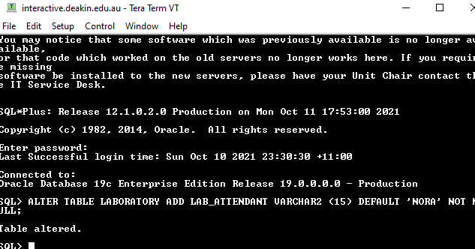

**SELECT PATIENT_CARD_NUM, REPORT, LAB_ATTENDANT, DOCTOR_NAME FROM LABORATORY;**

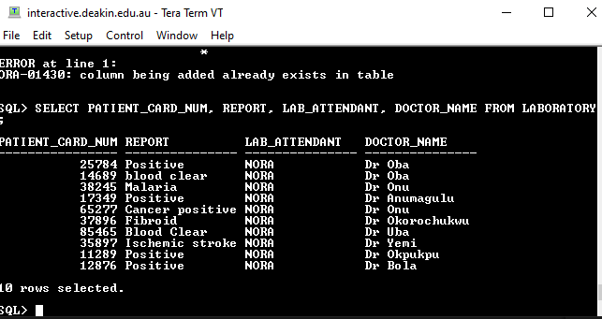

**b)** UPDATE TABLE:

**1**) I will be using patient_card_num as condition for example, where patient_card_num=11289.

**2) The new value will be REGINA.**

**SQL STATEMENT:**

1. **UPDATE LABORATORY SET LAB_ATTENDANT=’REGINA’ WHERE PATIENT_CARD_NUM=25784;**
2. **UPDATE LABORATORY SET LAB_ATTENDANT=’REGINA’ WHERE PATIENT_CARD_NUM=11289;**
3. **UPDATE LABORATORY SET LAB_ATTENDANT=’REGINA’ WHERE PATIENT_CARD_NUM=65277;**
4. **UPDATE LABORATORY SET LAB_ATTENDANT=’REGINA’ WHERE PATIENT_CARD_NUM=12876;**

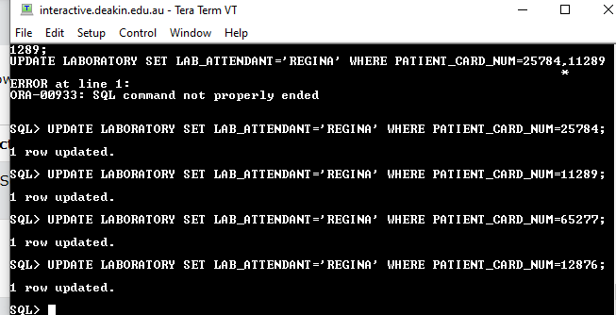

**SELECT PATIENT_CARD_NUM, REPORT, LAB_ATTENDANT, DOCTOR_NAME FROM LABORATORY;**

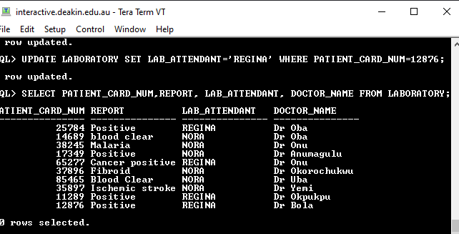

2.8) Data manipulation

2.8.1 a)Here I want to join two columns from a table and a column from another table then return the data starting with their last name.

**b) SELECT STAFF.LAST_NAME,STAFF.AREA,JOBTYPE.SALARY FROM STAFF INNER JOIN JOBTYPE ON STAFF.AREA=JOBTYPE.AREA ORDER BY STAFF.LAST_NAME;**

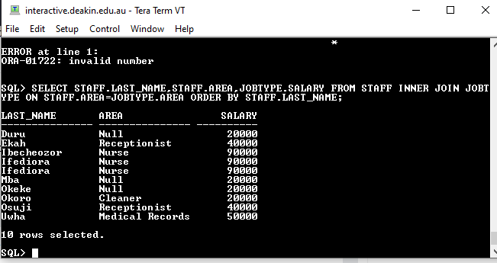

2.8.2 a) Here I want to list data in laboratory table that contains the ‘positive’ value in report using the column ‘patient_card_num’.

**b) SQL STATEMENT:**

**SELECT PATIENT_CARD_NUM,REPORT,DOCTOR_NAME FROM LABORATORY WHERE PATIENT_CARD_NUM IN (25784,17349,11289,12876);**

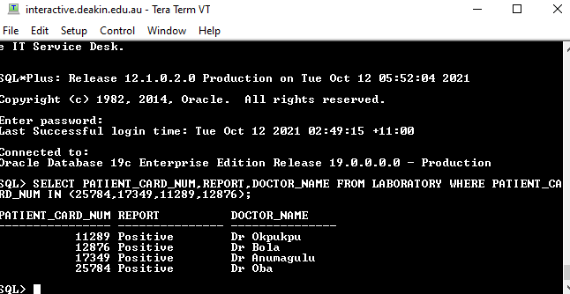

**2.8.3 a) I want to join a column from a table and a column from another table .**

**SQL STATEMENT:**

**b) Select staff.last_name, jobtype.area from staff full outer join jobtype on staff.area=jobtype.area;**

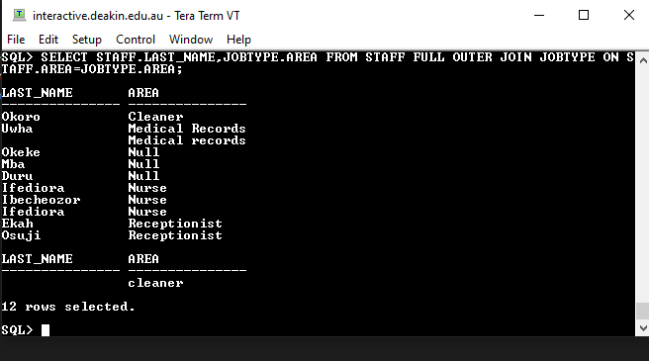

**2.8.4 a)** I want to return the current date using the ‘sysdate’ .

**b) SQL STATEMENT:**

**SELECT SYSDATE FROM DUAL;**

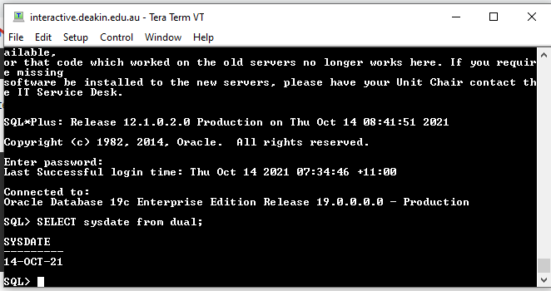

**2.8.5 a)** I want to join two tables hereby making it a table on its own which is done using ‘create view’

**b) SQL STATEMENT:**

**CREATE VIEW STAFF_JOB AS SELECT STAFF.LAST_NAME,JOBTYPE.AREA,JOBTYPE.SALARY FROM STAFF JOIN JOBTYPE ON STAFF.AREA=JOBTYPE.AREA WHERE JOBTYPE.SALARY=20000;**

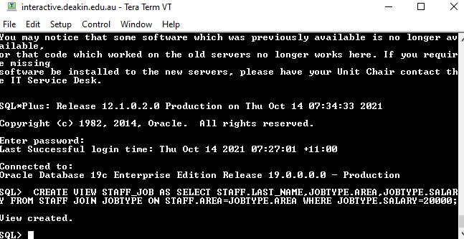

**SQL STATEMENT:**

**SELECT * FROM STAFF_JOB;**

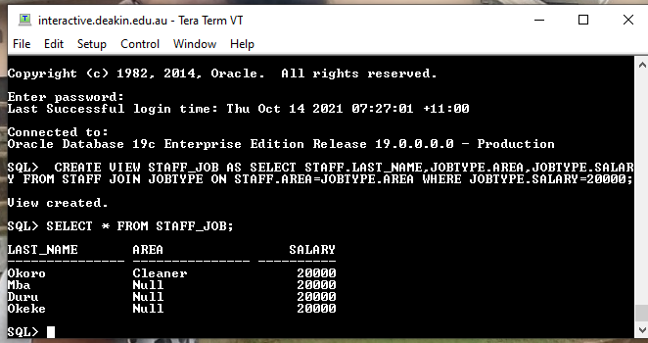

**2.9)Data** security is the practice of protecting digital information from unauthorized access or theft throughout its entire lifecycle as well as the prevention of intentional or accidental access from unauthorized users. Security professionals need to develop frameworks to guide the practical and theoretical security practices within the organization. (Susanto, 2011).

Privacy consideration refers to the right a person or company has to access data relating to them. It is also the limit to which accompany has to determine the details of their data.

## Some of the proven practices to minimize data breaches in God’s Knot Hospital.

1. Restriction of access to valuable data: God’s Knot Hospital is limit employees access to valuable data.
2. Security awareness training for employees: Employees are the weakest access to data security though even with training, they can still open suspicious emails but if been serious about safeguarding data the hospital can organize the training monthly.
3. Software should be updated regularly.
4. Impact and affirm/test the accuracy of the policy to third party

## Below are some of the Tools to help Data Security in the hospital.

**Access Control:** These are policies and procedures that an organization, e.g. (God’s knot hospital)needs to put in places to prevent inappropriate/unwarranted access to data by unauthorized staffs, Nurses, Doctors or even outsiders.

**Authentication:** This is the capability of knowing that someone is whom they claim to be.

1. Token: This is a physical device that is in form of an identification card that is designed to identify the single user.
2. Biometric authentication: This is also another tool that verifies one’s characteristics e.g., fingerprints or Retinal image.

PROCEDURES: This is step by step instructions that should be followed during the process of putting controls in place. Some of these procedures are:

1. Changing of passwords every six months.
2. All users must have passwords which meet certain criteria.
3. People are usually advised against using simple passwords that can be easily guessed.

2.10) Characteristics of Big Data and technologies used to deal with Big Data

Big Data comprises of a large (big) quantity/amount of data. Also, it refers to a collection of data sets.

Some of the characteristics of Big Data are:

1. Volume
2. Velocity
3. Variety
4. Veracity
5. Value
6. Validity
7. Virality etc.

But the three major characteristics of Big Data are;

1. Volume
2. Velocity and
3. Variety (3V’s)

|  |  |  |
| --- | --- | --- |
| Volume | Size of Data | This is the quantity of data that are collected and stored. |
| Velocity | Speed of Data | This is explained to be the rate at which data is transferred between the source and destination. |
| Variety | Type of Data | There are the different types of data such as, Videos, audio e.t.c received. |

Other characteristics of Big Data

|  |  |  |
| --- | --- | --- |
| Value | Importance of Data | This is the business value that is gotten from big data. |
| Veracity | Data Quality | This is the accurate analysis of data collected. Data is inconsequential if it is not authentic. It is also summarized to be the trustworthiness of data. |
| Virality | Spread Speed | This is the speed in which the data is spread by the user and received by other users. |

## Technologies that can be used to deal with Big Data

**Hadoop:** This method is used to give good processing performance even at a low-cost storage. It is being used to process large data sets.

The Hadoop products are unified into distributions such as:

1. Hadoop Distributed File System (HDFS)
2. MapReduce
3. HBase
4. Hive
5. Mahout
6. Pig etc.

Hadoop consists of two components which are Hadoop Distributed File System and MapReduce which is a structure for distributed processing data.

**HBase:** This requires irregular write or read activities on large data sets or for operations which have many clients.

**Hive:** This is used to also manage large data sets from distributed storage. It also contains SQL query language named HiveQL.

**Mahout:** This is an information Centre for data mining and also machine-learning algorithms which includes clustering algorithms and classification. Several data are written for affinity with MapReduce that they are scalable to big data.

**Pig:** This is another technology used for resolving big data sets. This Pig has a particular language used for defining data analysis programs.

The focus of the processing aspect of the big data system is to ensure that the data can be processed in batch as well as in real-time in alignment with the business objectives. The structured and unstructured information is combined at this stage to generate usable data for further data consumption, processing, and warehousing. (Adriana S and Dora T, 2016)

## Some tips to take for managing Big Data in the organization (God’s Knot Hospital).

1. **Determine your goals:** Firstly, you have to set the objectives of the organization as well as outlining the strategies to achieve them. These objectives and strategies should be discussed with the team. This tip is important because without outlining the strategies, the company might end up going to the wrong data or collecting insufficient data.
2. **Securing the data:** This is making sure that the hospital do not lose their data by securing and accessing the data.
3. **Protecting the data:** Apart from the threat we have to protect our data, from intruders. Natural elements like heat, extreme cold and humidity can also pose as potential harm to data.

**Apache Hadoop:** It allows faster data processing, and it gives flexibility to the processing data etc.

**HPCC:** This is one of the big data processing tools that give’s high redundancy, and it also accomplishes big data tasks using less code efficiently.

We also have other tools such as; Qubole, storm, Cassandra, statwing, CouchDB

**REFERENCE LIST**

Sunil Ladekar (July 2014) ‘*Best practices for information security breachmanagement*’ East Carolina University, accessed on 26th September, 2021. <<https://www.researchgate.net/publication/264084730_Best_Practices_for_Information_Security_Breach_Management>>

IBM (n.d) *What is data security?*<<https://www.ibm.com/topics/data-security>> accessed on 23 September 2021.

Fedinand J.K 2015, ‘*Best practices to minimize data security*’ Walden university, <[https://scholarworks.waldenu.edu/cgi/viewcontent.cgi?article=2928&context=dissertation](https://scholarworks.waldenu.edu/cgi/viewcontent.cgi?article=2928&context=dissertations)>accessed on 25th September, 2021.

Coronel T, and Morris R 2018, ‘*Database system’, design,* implementation and management 13th edition (738, 16-2).

Gayatri K, Alka A, and KhanR.A 2016, ‘*A study of Big Data Characteristics*’, Ambedkar University,<<https://www.researchgate.net/publication/315867458_A_study_of_big_data_characteristics>>accessed on 26th September, 2021.

Alexandru A, Alexandru C.AandTudora E 2016, *‘Using Big Data Technologies in Government Computer’*<<https://www.researchgate.net/publication/310415976_Big_data_Concepts_Technologies_and_Applications_in_the_Public_Sector>>accessed on 26th September 2021.

Subhankar D and Sourav M2014, ‘*Challenges and Best Practices for Enterprise Adoption of Big Data Technologies’* Information Technology Management, San Jose State University and IBM Software Group, <<http://jitm.ubalt.edu/XXV-4/article4.pdf>>accessed on 1st October, 2021.

SmartDataCollective (n.d) <<https://www.smartdatacollective.com/7-helpful-tips-managing-big-data/>> accessed on 3rd October, 2021

David T 2021, ‘*Top 15 big data tools and software’*<<https://www.guru99.com/big-data-tools.html>> accessed on 3rd October, 2021.